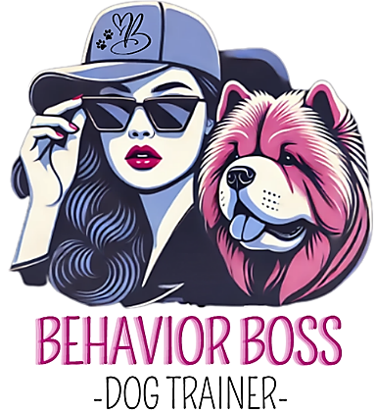
NEW CLIENT QUESTIONNAIRE:

This questionnaire will help us better understand your needs and goals. Please take a few moments to answer the following questions:

General Information
- Your Name:_____________________________
- Your Email Address:____________________________
- Your Phone Number:________________________
- What type of service are you interested in?
__Basic Obedience Training Program
__Board & Train Program
__Behavior Modification Program
__Other:____________________________________________

About Your Dog
- Dog’s Name:_____________________________
- Breed or Mix:__________________________
- Age:_______________
- Gender: M / F
- Has your dog been spayed or neutered? Y/N
- Is your dog potty trained? Y/N
Training and Behavior

- Has your dog previously had any professional training? Y / N
1a. If yes, what type of training?
- What specific behaviors or issues would you like to address? _______________________________________________________________
_______________________________________________________________
- What commands, if any, does your dog know?_________________________
_________________________________________________________________
- On a scale of 1-5, how obedient do you feel your dog is currently?
(1 = Not Obedient, 5 = Very Obedient)
- Does your dog show signs of aggression (toward people, other dogs, or objects)? Y / N
(If yes, please specify)____________________________________________
- On a scale of 1-5, how well does your dog socialize with other dogs?
(1 = Does not socialize, 5 = Excellent social skills)

Daily Life

- How much exercise does your dog get daily? _______________________
- Do you feel your dog is getting enough mental stimulation? Y / N
- On a scale of 1-5, how well does your dog adapt to new environments or changes?
(1 = Poorly, 5 = Easily)
- Does your dog have any dietary restrictions or allergies? Y / N
(If yes, please specify):

Goals and Expectations

- What are your top goals for your dog’s training or behavior improvement?
___________________________________________________________________
- On a scale of 1-5, how confident are you in working with your dog on training at home?
(1 = Not Confident, 5 = Very Confident)
- Do you have any specific questions or concerns for us?
____________________________________________________________________
____________________________________________________________________

HOW DID YOU HEAR ABOUT US?
- Referral
  - If so, who? _______________________
- Facebook market place add_______
- Flyer____

